**Using Microsoft Hosted Agent**

* <https://learn.microsoft.com/en-us/azure/devops/pipelines/agents/hosted?view=azure-devops&tabs=yaml#software> for the list of microsoft hosted agents
* Setting up Microsoft hosted agents (Watch the classroom video)
* Create a pipeline for game of life which use jdk 8

---

trigger:

- master

jobs:

- job: buildjob

displayName: Build and Package Game of life

pool:

vmImage: ubuntu-22.04

steps:

- task: Maven@3

inputs:

mavenPOMFile: 'pom.xml'

goals: 'package'

publishJUnitResults: true

testResultsFiles: '**/surefire-reports/TEST-*.xml'

javaHomeOption: 'JDKVersion'

jdkVersionOption: '1.8'

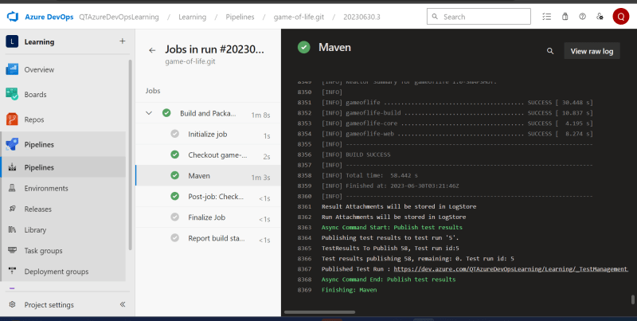

* Azure DevOps Pipleine Variables <https://learn.microsoft.com/en-us/azure/devops/pipelines/process/variables?view=azure-devops&tabs=yaml%2Cbatch>
* Azure DevOps has predefined variables <https://learn.microsoft.com/en-us/azure/devops/pipelines/build/variables?view=azure-devops&tabs=yaml#agent-variables-devops-services>

---

trigger:

- master

jobs:

- job: buildjob

displayName: Build and Package Game of life

pool:

vmImage: ubuntu-22.04

steps:

- task: Maven@3

inputs:

mavenPOMFile: 'pom.xml'

goals: 'package'

publishJUnitResults: true

testResultsFiles: '**/surefire-reports/TEST-*.xml'

javaHomeOption: 'JDKVersion'

jdkVersionOption: '1.8'

- task: CopyFiles@2

inputs:

Contents: "**/target/gameoflife.war"

TargetFolder: $(Build.ArtifactStagingDirectory)

* Lets use Publish build artifacts to acheive the same result <https://learn.microsoft.com/en-us/azure/devops/pipelines/tasks/reference/publish-build-artifacts-v1?view=azure-pipelines>

---

trigger:

- master

jobs:

- job: buildjob

displayName: Build and Package Game of life

pool:

vmImage: ubuntu-22.04

steps:

- task: Maven@3

inputs:

mavenPOMFile: 'pom.xml'

goals: 'package'

publishJUnitResults: true

testResultsFiles: '**/surefire-reports/TEST-*.xml'

javaHomeOption: 'JDKVersion'

jdkVersionOption: '1.8'

- task: CopyFiles@2

inputs:

Contents: "**/target/gameoflife.war"

TargetFolder: $(Build.ArtifactStagingDirectory)

- task: PublishBuildArtifacts@1

inputs:

pathToPublish: $(Build.ArtifactStagingDirectory)

artifactName: GameOfLifeArtifacts

